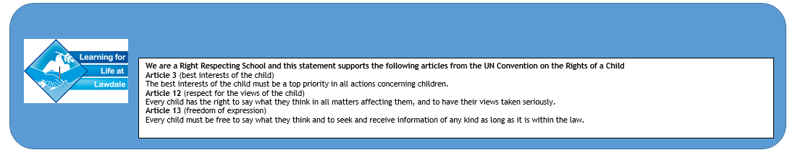
Year 3, Spring Term
Levers and Linkages

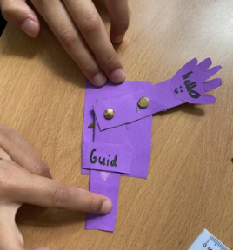

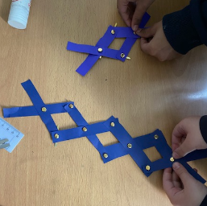

Year 3 looked a range of mechanisms and how they create movement. They explored and used mechanisms, such as sliders and levers.

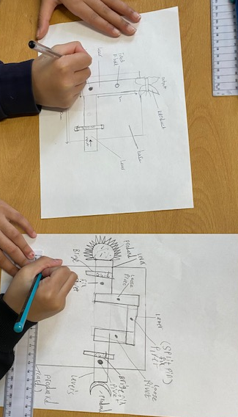
Then they planned and designed a product criteria, meeting the needs of the user. They annotated their sketches and prototypes to develop, model and communicate ideas.

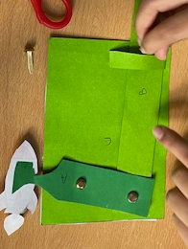
Year 3 then used a range of techniques to create a prototype of developing ideas. They selected and used appropriate tools to cut and join. They practised moving levers around fixed and loose pivots.

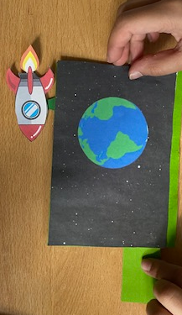

They used a range of techniques to complete their final product and tested it against the design criteria.
They evaluated their final product, considering the views of others.

